DEPARTMENT OF INFORMATION TECHNOLOGY
FACULTY OF ENGINEERING & TECHNOLOGY

MINI PROJECT REPORT

ON

FOOD SAFETY PORTAL

PRANAV GUPTA (RA1611008010100)
SHARDUL SILSWAL (RA1611008010660)
VIKENDU SINGH (RA1611008010160)

SUBJECT CODE: 15SE203

SUBJECT TITLE: OBJECT ORIENTED ANALYSIS AND DESIGN



SRM Institute of Science and Technology, SRM Nagar
Kattankulathur, Kancheepuram District

Rubrics

Experiment Component | Max. Marks | Grading Rubrics
Documentation/  Procedure | 10 | UML Diagram’s are well documented. The documentation supporting all functional requirement and non-functional requirement(10 Marks) |  | Missing two or more required functional requirement .The documentation work not up to the mark. (5 Mark)
Concept | 5 | Completeness of concept, consistent variable naming and relationship in static view. (5 Marks) | Completeness of concept, inconsistent variable naming and relationship in static view. (3 Marks) |  | Incomplete static view. (1 Mark)
Usage of Symbols | 3 | Precise usage of symbols in dynamic view.  (3 Marks) | Improper usage of Symbol’s.  (2 Marks) |  | Symbol’s misplaced in diagram. (1 Mark)
Diagrams | 4 | Completion of all 8 UML Diagrams using Visual Paradigm Tool. (4 Marks) | Construction of UML Diagrams using other tools. (2 Marks) |  | Construction of few diagrams’. (1 Mark)
Viva and Innovative Idea | 3 | Oral Viva and Innovative approach. (3 Marks) | Oral Viva and partial idea. (2 Marks) |  | Oral Viva not fulfilled. (1 Mark)
TOTAL | 25

Table of Contents

S. No | Particulars
1 | Abstract
2 | Module Description
3 | Use Case Diagram
4 | Class Diagram
5 | Sequence Diagram
6 | Activity Diagram
7 | Swim Lane Diagram
8 | Start Machine Diagram
9 | Component Diagram
10 | Deployment Diagram
11 | Conclusion

15SE203-OOAD-Mini Project(Rubrics) |  |  |  |  | Title:
 | 1 | 2 |  | 3 |  | 5 | Total
Application Components | Concept [5] | Usage of Symbols[5] |  | Diagram and Layout [10] |  | Innovative ideas[5] | 25
Marks awarded
Staff Signature |  |  |  |  |  | Total Marks (Max = 25)

Abstract

Objective:
To provide an application which allows residents and visitors of a city to find out more about food related aspects about the city. Aspects include information about restaurants and market certifications and what to look for local diets and/or delicacies, or even a restaurant guide.
Users of the System:
1. City residents
2. Visitors
3. City employees
Attributes of the model:
1. User accounts
2. Review forms
3. Comments/Complaints
4. Rating
5. Search restaurants
6. View Restaurants
7. Modify accounts
8. Update website

Requirements:
Hardware:
Processor: Intel Pentium or above
Hard disk: 2 GB of available space
Ram: 512MB
DVD drive: (recommended)
Software:
Application: Star UML
Operating System: Windows XP (or above)/Linux/Mac

Module Description

There are three basic users –
- City Residents
- Visitors
- City Employees.

All users have their own profiles in FSP.

City residents and visitors can search for restaurants and make online booking. They can also submit feedback on any restaurant.

City employees can view record of their customers (regular customers, weekend customer or new customers).

Restaurant guide views and manages the booking, performs day open and close activities and calculates his commission. He also sends reports to admin.

Admin has the authority to add/delete users, grant permission to city employees and restaurant guide to generate and view. He also views the complains and feedback of users and takes necessary actions.

UML DIAGRAMS

Use Case Diagram

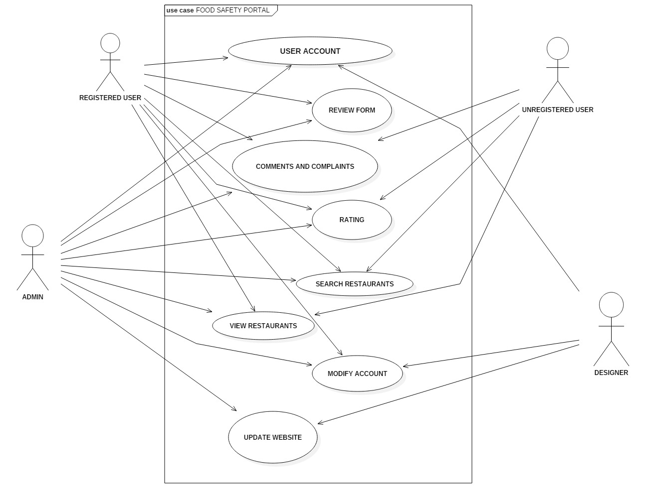

The use case diagram features the users of the system along with the services offered to the users. The actors in the diagram are users, admin, restaurant and designer. The diagram showcases the services like creating account, searching restaurants, see ratings, give feedback, file complaints, etc. It also includes the payroll of the employee along with any perks or bonuses to be added in the salary.

Class Diagram

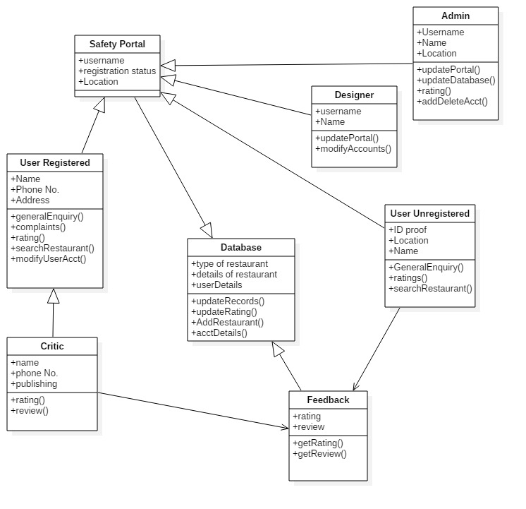
The class diagram is composed of various classes having different attributes. All the classes are interconnected to each other. The administrator and employee class are connected to the people class as the attribute of this class distinguish between them. Further the database keeps a record of thr feedback input by registered, unregistered user and the admin.
Sequence Diagram

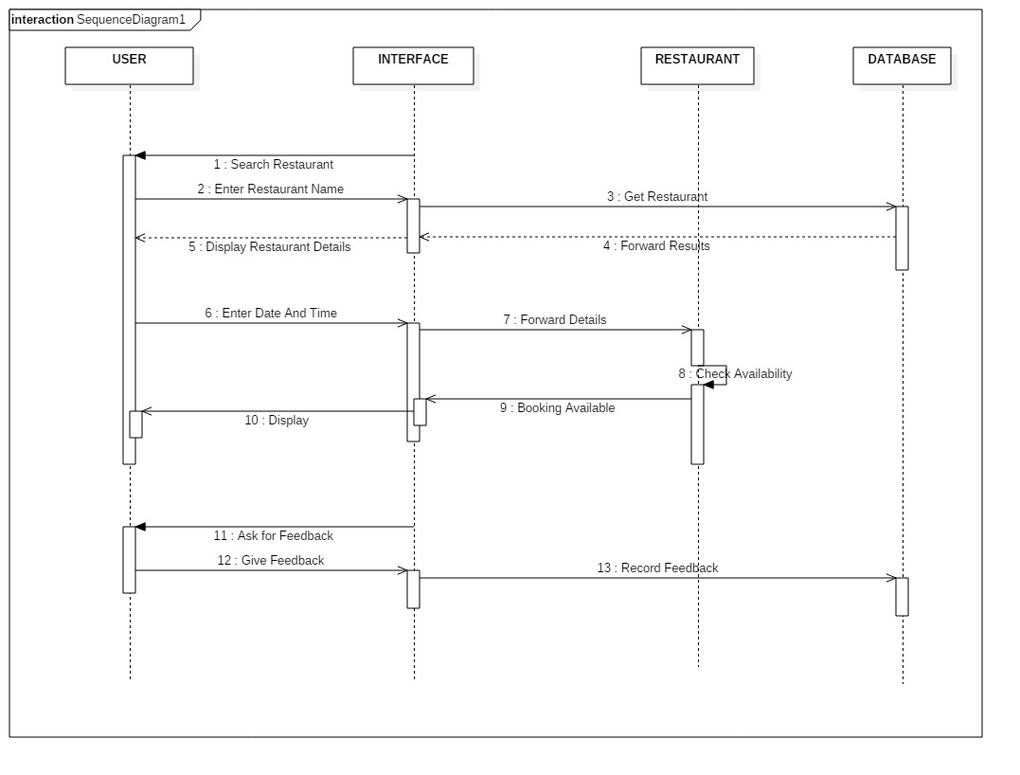
The sequence diagram consists of the user, interface, restaurant, and the database.
Firstly, the user inputs his review of the eatery and then through the interface it is approved by the admin and uploaded to the database by the System designer.
At this stage the review is visible to everyone including unregistered user.
Activity Diagram

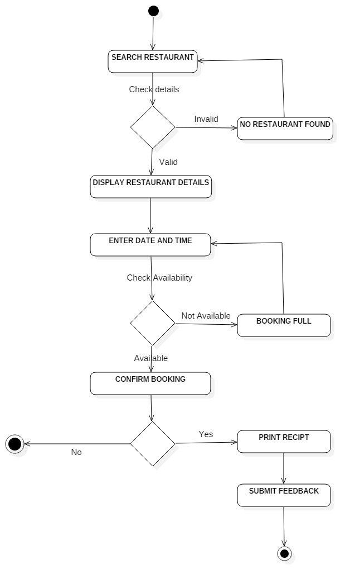
In the activity diagram the user is asked about the restaurant details and the corresponding reviews of various restaurants show up.
Which can be separately seen as either by Registered User and/or by unregistered user.

Swim Lane diagram

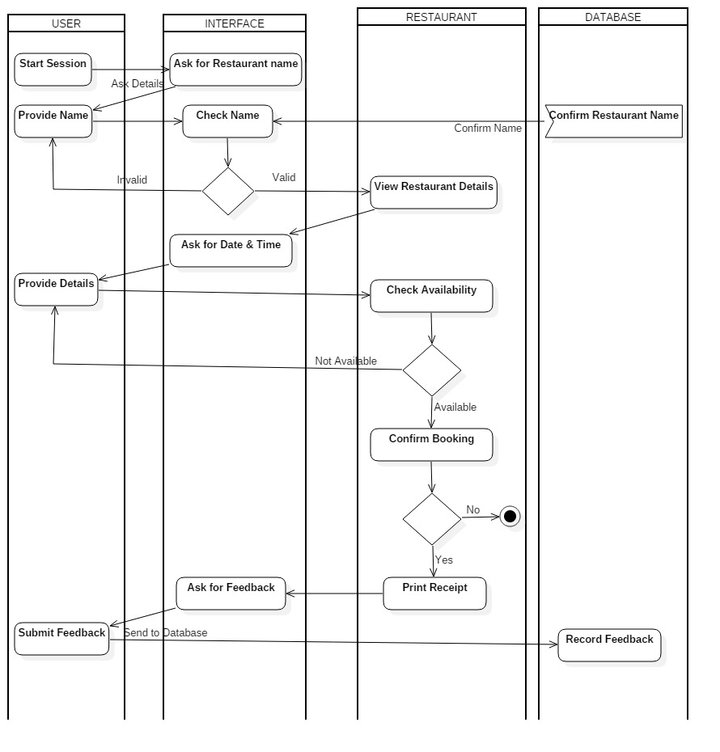
The session starts with the portal asking the user for a restaurant name, address and the corresponding name along with reviews show up . This portal also enables the user to contact the restaurant directly for a booking. Furthermore, the portal gives the option of reviewing the restaurant after the user dined there.
Start Machine diagram

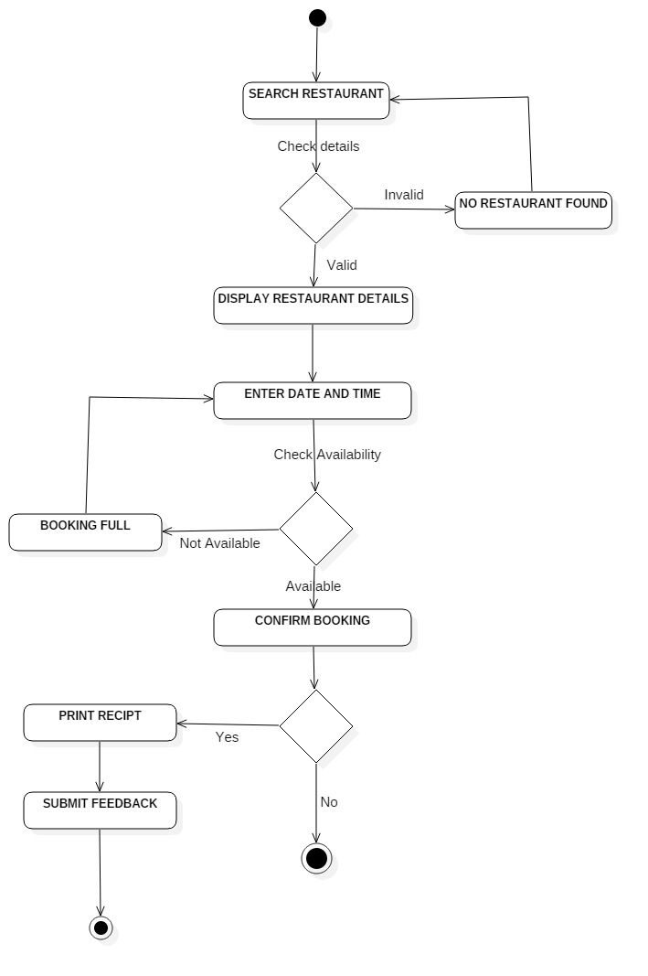
The start machine diagram starts with the restaurant details, if the input is correct then the portal will direct you to the reviews section of that particular restaurant.
It will also help you to book and confirm your booking with the restaurant, it also provides a payment gateway to do so.
Component diagram

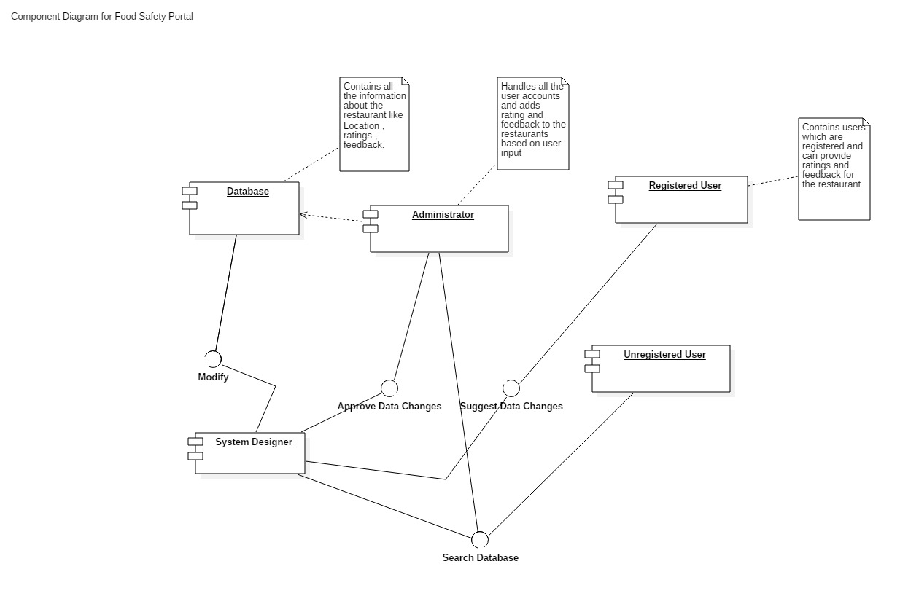
The component diagram is composed of 5 components; The registered user, the unregistered user, the admin and the system designer along with the database.
The database gets the restaurant details after they have been entered by the user of all kind and further approved by the admin.
The system designer in this responsible for the maintenance of the interface and updating it regularly.
Deployment diagram

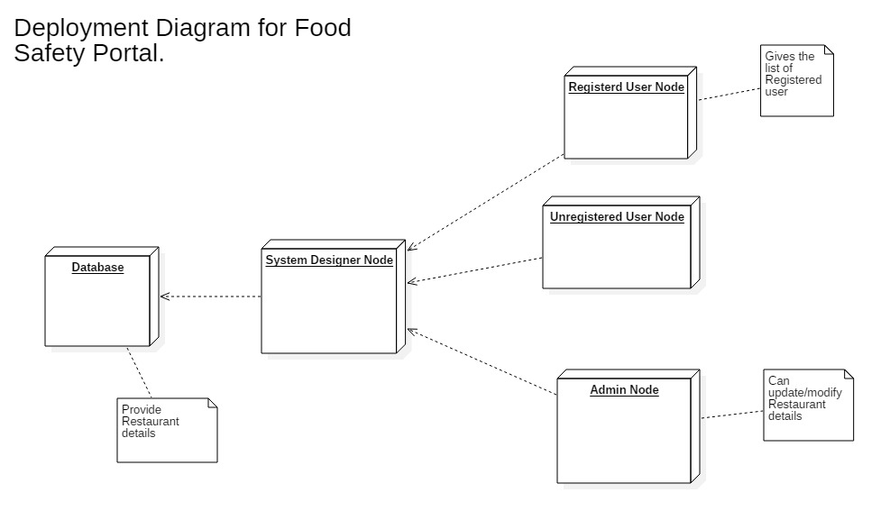
The deployment diagram consists of total 5 nodes;
The database holds the information about each and every restaurant.
The User nodes contain information about the users like when and where they submitted information about any restaurant.
The admin node is responsible for approving all the information that has been entered by the users.
Conclusion

Food Safety plays an important role in any Locality/City. The food safety portal will help users far and near determine whether or not a place has been reviewed positively or negatively by the vast majority of the users.

While we were doing this project, we understood that Food Safety has a major role to play in the health and well being of a Locality. And to improve the present state of the society the Food Safety Portal must be treated properly as it forms an integral part of the society.

We understood the need for OOAD as it helps in defining the structure and the working of a system so that we can refer it whenever needed. All the diagrams helped us to understand the functioning of the system efficiently.

